Application Setup: Simply download all the files into the same folder. Open the python file and run it to see your results!

Project Motivation: Convert vote counting methods used in real life into algorithms that can be used to automate existing tasks.

The program takes the following type of polling data where each row is the order of preference of a voter, where first position implies first preference.

For example, consider an election with five candidates whom we will call A, B, C, D and E. One voter might rank the candidates this way: DABCE

Expected types of input:

Example (Plurality,Majority, and Borda methods) Example (Approval and Condorcet methods)

 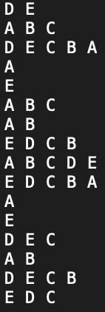

Expected output:

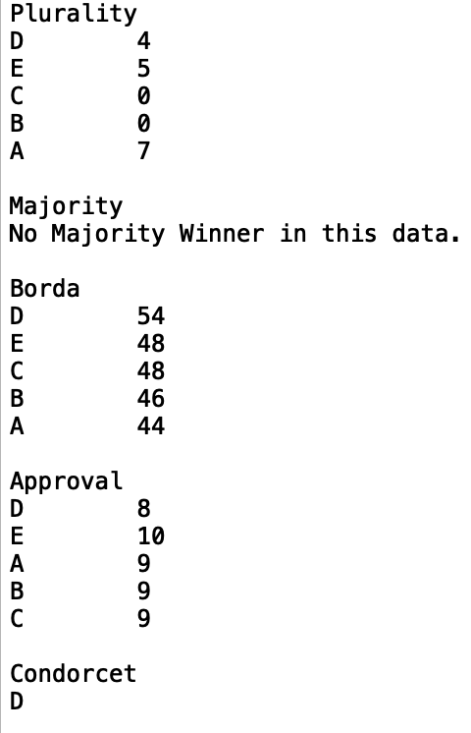

After accepting the input data, the program runs five different methods of polling, all algorithms of which run in O(n) time, to conduct different types of polling analysis on the data.

A Plurality winner is the candidate with the most amount of first preference votes.

A Majority winner is the candidate who was able to achieve more than 50% of the first preference votes.

A broda winner is decided by assigning a weight to the preference ranking votes, adding them all up and then declaring a winner, which is the candidate with the most points.

An Approval winner is decided where voters may vote for candidates that they approve off, here, ranking does not matter. The candidate with the most votes wins.

A Condorcet winner is a candidate who would win a two candidate election against all the other candidates in a plurality vote.